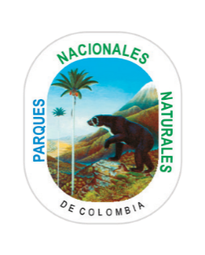

**SATISFACTION SURVEY**

**Territorial Directions, Central Level and Administrative Office of the Protected Areas**

**Código:** AU_FO_14

**Versión**: 4

**Vigente desde dd/mm/aaaa:** 06/07/2018

**¡YOUR OPINION IS IMPORTANT!**

**For National Natural Parks of Colombia your opinion is very important to improve your experience in our offices. We appreciate fill this survey. Please return this document complete to the staff.**

**AUTHORIZATION TO PROCESS PERSONAL DATA**

I authorize to Natural National Parks of Colombia for the collection, storage, use and update of my data, with the aim of improving the communication user - entity; promote access to our procedures and services; evaluate the quality of the service; keep a record of the number of users; studies on consumption habits; to make characterization of users and receive information about topics related to the functions of the entity, the services it provide and the publications that makes National Parks. The procedure for consult, claim and make effective your rights, will be enable in the following address: [http://www.parquesnacionales.gov.co/portal/es /Proteccion-de-Datos-Personales /](http://www.parquesnacionales.gov.co/portal/es%20/Proteccion-de-Datos-Personales%20/)

 Yes  No

**Sign:** ___________________________________________________

|  |  |  |  |
| --- | --- | --- | --- |
| Date: DD/MM/YY | City: | Gender: F ___ M___ | |
| Name and Surname: __________________________________________________________________ | | | |
| E- mail: ____________________________________ Phone number: _________________ | | | Country: __________________________ |
| Age: 16 to 25 26 to 35 35 to 60 Older than 60 | | | |
| Check with an “X” :  Do you think is easy the access to the offices: YES NO    Do you think is easy the access to our procedures and services: YES NO  Which mechanisms do you use to access to our services? Web Offices Telephone Natural National Parks App | | | |
| According to your experience, qualify our service:  Excellent Good Regular Poor   * ATTENTION SCHEDULE * THE ATTENTION TO YOUR DOUBTS WAS KIND, TIMELY AND CLEAR * STAFF ATTITUDE * ATTENTION AND SERVICE RECEIVED * FACILITIES * WAITING TIME | | | |
| ¿What is the reason for your visit?  Ecotourism Geographical information  Volunteer Park Rangers Program Make a Reservation  Environmental procedures Information about properties  Information about National Parks Petitions, Requests, Claims  Other: Which? ­______________________________ | | | |
| Which services you want to find in your next visit? | | | |

